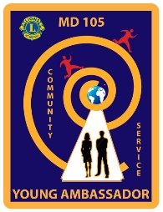

MULTIPLE DISTRICT 105
YOUNG AMBASSADOR
OF THE 21ST CENTURY

Information and Consent Form

Venue: Village Hotel, Dudley | 17th – 19th February 2023

Name of Young Ambassador Candidate, name of supporting Lions’ Club and email contact details
Name of any member of the Young Ambassador candidate’s family staying in Dudley. If staying in Dudley, in which hotel?
Address of candidate

Date of birth

Candidate’s contact details: Telephone numbers (home and mobile) and email address
Name, address, email and phone numbers of emergency contact

Name, address and contact details of candidate’s doctor

Is the candidate receiving any medication or treatment at present? Yes*/No*. If yes, please give details

Is the candidate allergic to anything? e.g. antibiotics, any particular food or drink? Yes*/No*. If yes, please give details

Please continue on page 2

Attendance at Finals and Consent for Medical Treatment and Publicity

DATA PROTECTION
All personal data and/or special category data are processed in accordance with UK data protection legislation. All feasible security measures are in place.
I understand that all information is freely given for processing as may be required for the competition and its administration, including retention. I also understand that data may be transferred outside the UK.

Signature ________________________________ Date: _______________

If you prefer to be contacted by one or more specific media, please let us know the appropriate details here:

Email:
Mobile Phone:
(call or text or both)
Postal address:

